Maths for this project

This document is to record my thought process regarding mathematical problems in this project.

# Calculating the degrees of the servos relative to the user pose

I need to calculate the degrees of the joints for my servo’s.

This image displays my initial thoughts about solving the problem.

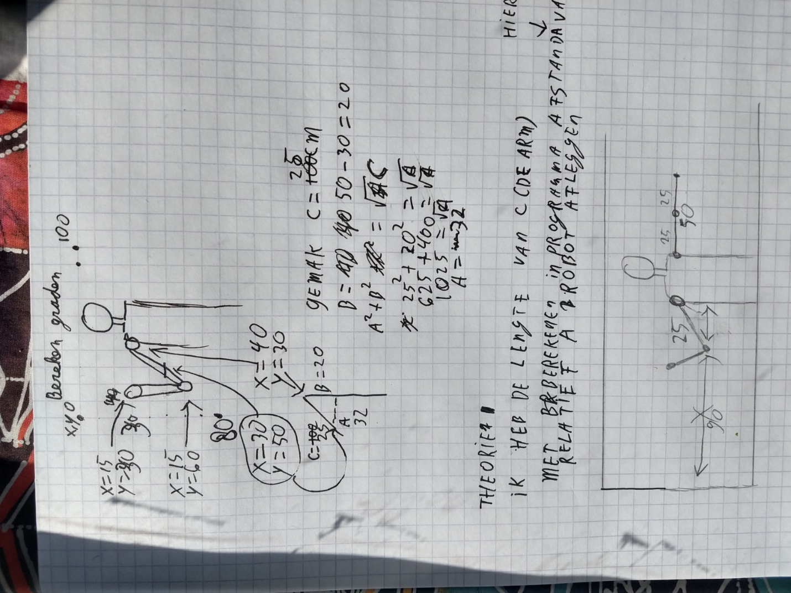

Basically I use the coordinates given by the program. Using these coordinates I can create an triangle. But there is a problem. I only get the coordinates of my shoulder and elbow(for the first calculation anyway). I first need to calculate the position for the conversion point. The next drawing should show what I’m trying to say. The coordinates are made up and do not reflect the drawing.

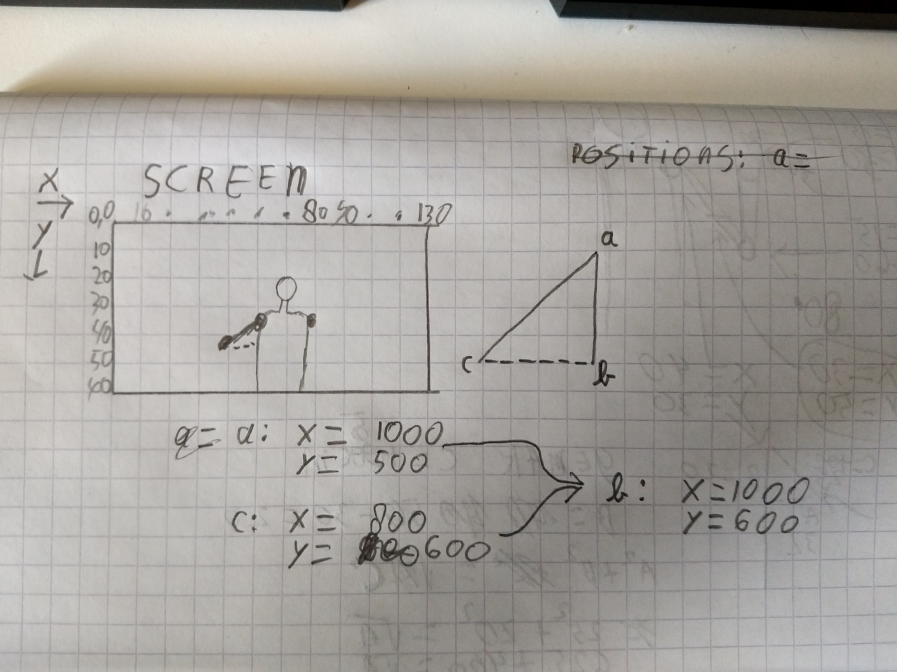

The positions of a(shoulder) and c(elbow) are given by the program. With this data b can be calculated.

Now all the points are known we can calculate the distances. These distances are relative but not the same as wat is being recorded in real live. Using these relative distances we can calculate the angles.

**Distances**

**ab: 500 -600 = -100. Absolute: 100 units**

**bc: 1000 – 800 = 200 units**

**ac(we dont need this, but why not): 1002  + 2002 = root ac. --> 10000 + 40,000= 50,000. The root of 50,000 ~= 223.61 units**

## Finally, we can calculate the angle of corner a.

For this calculation i used <https://www.mathsisfun.com/sine-cosine-tangent.html> as reference.

The sides are already known. They now need the correct names.

Ab = adjacent

Bc = opposite

Ac = hypotenuse.

Using these sides I can calculate the angle of a.

<https://developer.mozilla.org/en-US/docs/Web/JavaScript/Reference/Global_Objects/Math/atan>

Basically I need to execute this formula:

(Math.atan(opposite / adjacent) * 180) / Math.PI

Translated to calculator: (tan-1(opposite/adjacent) *180) / PI.

## What direction is the shoulder joint for arm up or down

Now we get the correct angles of the servo’s, we don’t know what side the arm should be aimed at. For example:

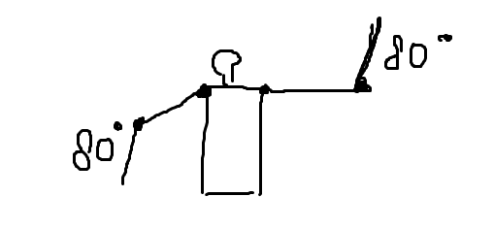

Both sides are 80 degrees but the arms in both cases will be positioned the same. Here comes the z servo in place. When the z shoulder servo is 0 degrees, you get the correct left arm. The same is for z servo 90 degress, the right arm is positioned correctly.

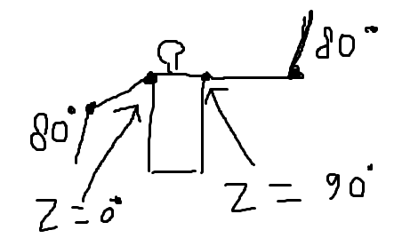

To get these values I will simply check if the y axis of the elbow is higher or lower than the shoulder y axis